# steps to create a package using MSIX

## Prepare your document preparation application: Ensure your application is ready for packaging, including any dependencies or prerequisites.

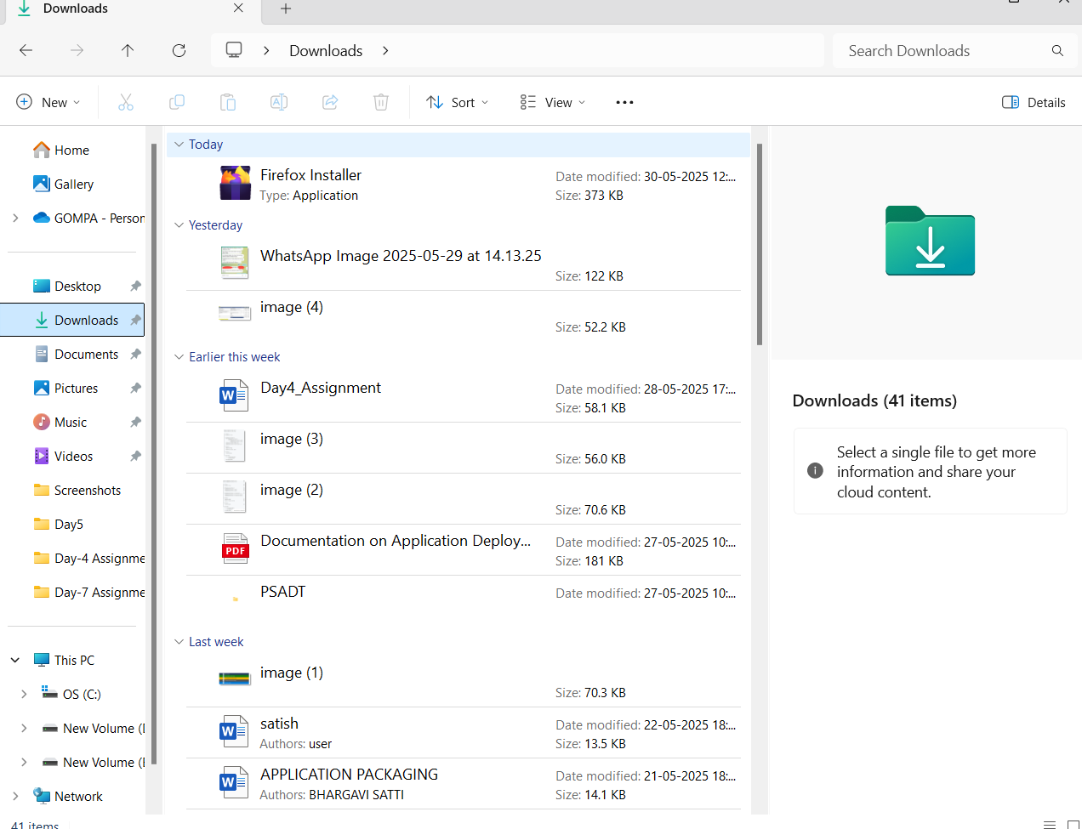

* **Choose a packaging tool: Select a suitable tool, such as MSIX Packaging Tool or Advanced Installer.**

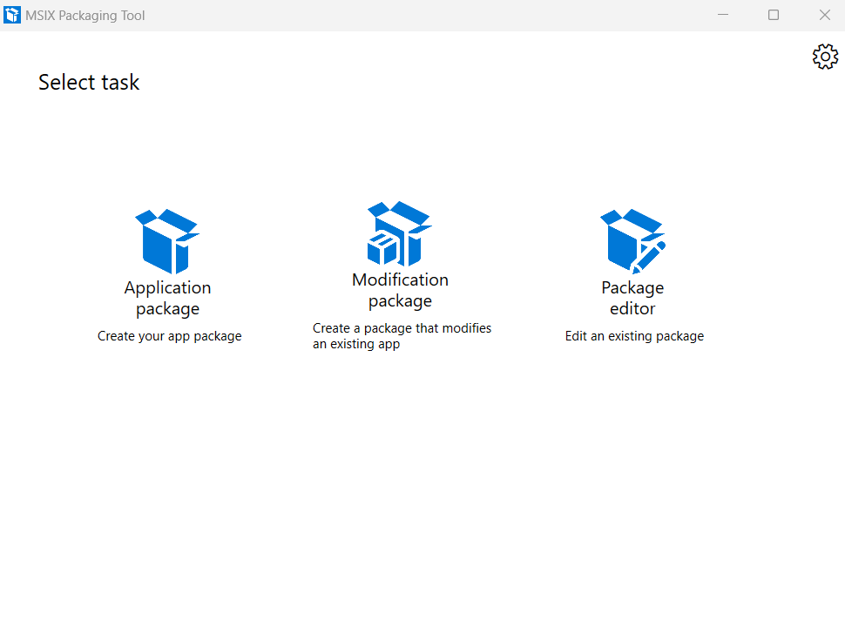

* **Create a new package: Launch the chosen tool and create a new MSIX package project**.

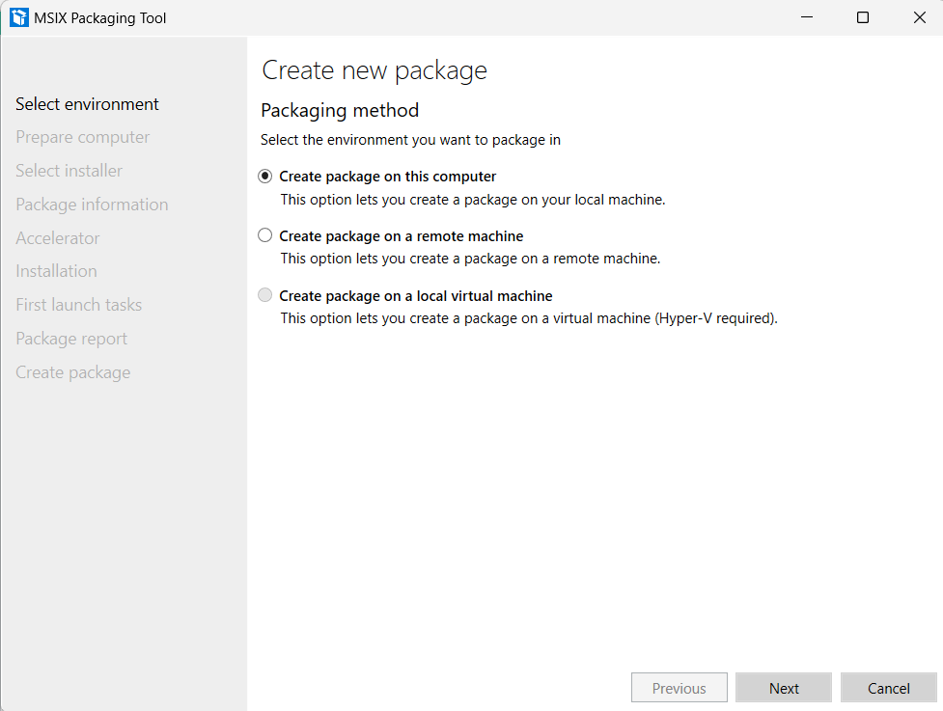

**Specify package details: Enter package information, such as:**

* + - **Package name and version**
    - **Publisher and identity details**
    - 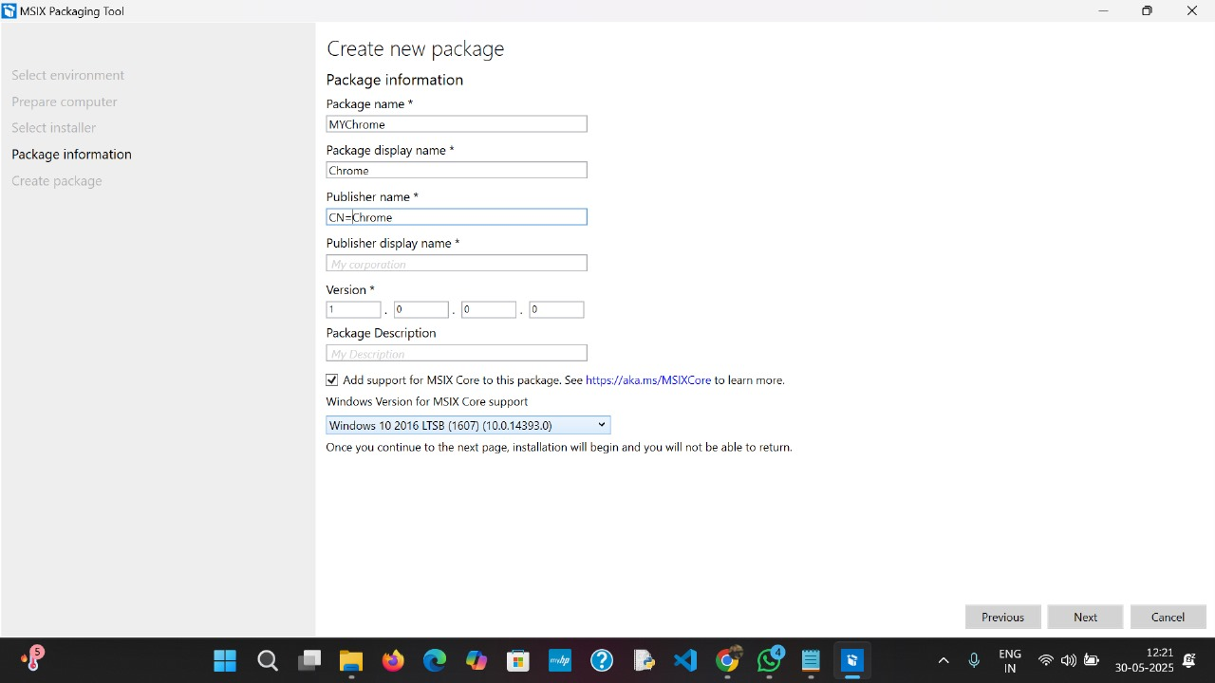Dependencies (e.g., Microsoft Office)

**Add application files: Include your document preparation application's files.**

**Configure package settings**: Set package settings, such as:

* We have to give Installation location and behavior

**Test the package:** Test the package on various environments.